**E-Project: Star Brand**

STAR BRAND

Source Code With Commment

|  |  |  |
| --- | --- | --- |
| **Supervisor.** | Sir Shakir Khan | |
| **Batch.** | 2305E1 | |
| **Group.** | 02 | |
| **Serial No.** | **Enrollment No.** | **Student Name** |
| 1. | Student1478236 | Atta Muhammad |
| 2. | Student1478241 | Hassan ullah |
| 3. | Student1477700 | Aniqa Tauseef |
|  |  |  |

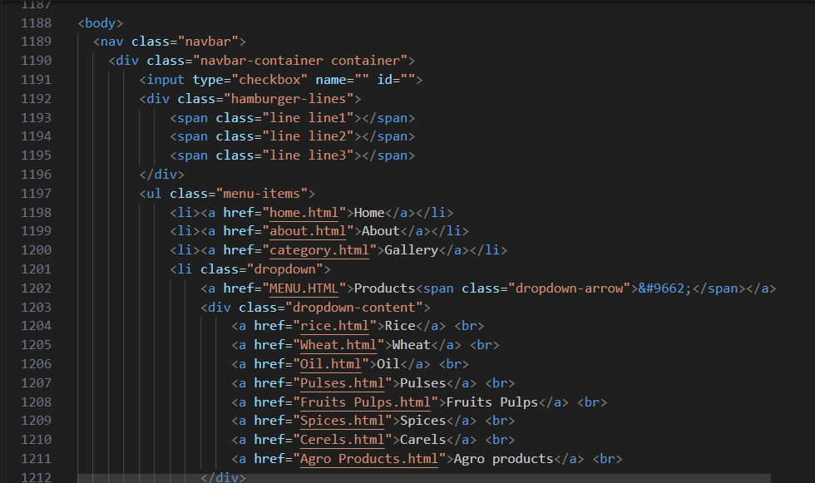

HTML Code Of NavBar :

1. <nav class="navbar">: This is a <nav> element with the class "navbar." It likely represents the website's navigation bar.
2. <div class="navbar-container container">: This is a <div> element with the classes "navbar-container" and "container." It is part of the navigation bar and contains the various navigation elements.
3. <input type="checkbox" name="" id="">: This is an input element of type checkbox. It might be used for creating a responsive menu or navigation bar that can be toggled on or off. However, the name and id attributes are left empty in the provided code.
4. <div class="hamburger-lines">: This is another <div> element with the class "hamburger-lines." It may be used to represent a hamburger menu icon, typically used on mobile or smaller screens.
5. Inside the "hamburger-lines" <div>, there are three <span> elements with classes "line1," "line2," and "line3." These are likely used to create the three lines of the hamburger menu icon.
6. <ul class="menu-items">: This is an unordered list (list of menu items) with the class "menu-items." It contains a series of list items that are typically used for navigation links.
7. Inside the <ul>, there are several <li> elements, each containing an <a> (anchor) element, which is used for creating clickable links. The links include:
   * "Home" with a link to "home.html."
   * "About" with a link to "about.html."
   * "Gallery" with a link to "category.html."
   * A dropdown menu item labeled "Products" with a down-arrow indicator.
     + Inside the dropdown, there are multiple links to various product categories, each with a link to a different HTML page.

CSS Code Of NavBar :

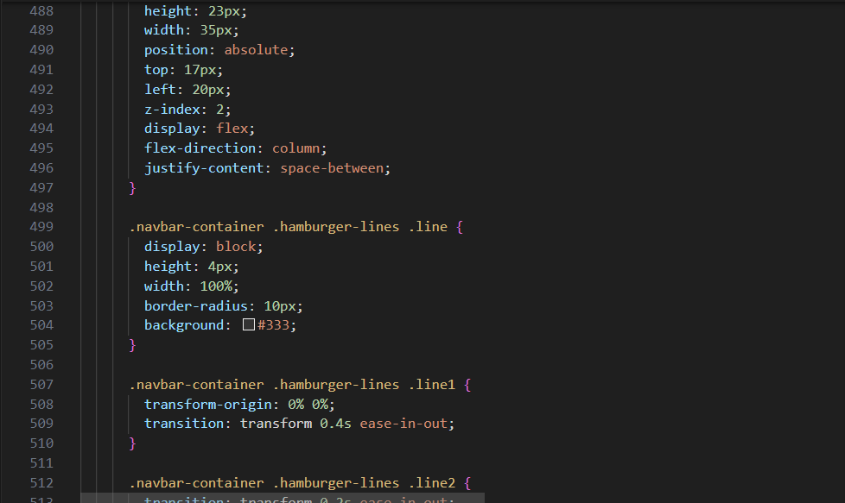

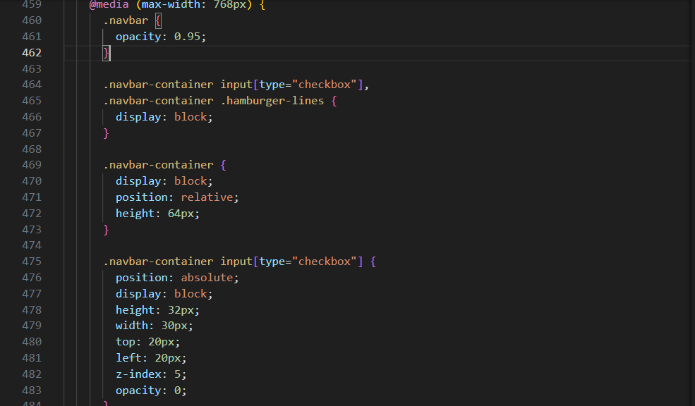

This is a CSS code snippet that appears to be related to the styling of a navigation bar and menu for a website. Let's describe the code in English:

1. **.navbar**:
   * The opacity of elements with the class "navbar" is set to 0.95, making them slightly transparent.
2. **.navbar-container input[type="checkbox"]** and **.navbar-container .hamburger-lines**:
   * The checkbox input and the elements with the class "hamburger-lines" within elements with the class "navbar-container" are set to be displayed as visible (block).
3. **.navbar-container**:
   * Elements with the class "navbar-container" are displayed as blocks.
   * They are positioned relatively, meaning their position is based on the normal flow of the document.
   * The height of these elements is set to 64 pixels.
4. **.navbar-container input[type="checkbox"]**:
   * The checkbox input within "navbar-container" is positioned absolutely, meaning its position is based on the nearest positioned ancestor.
   * It has a visible block display and specific dimensions (height and width).
   * It is positioned at coordinates (20px from the top and 20px from the left) with a z-index of 5.
   * The opacity of the checkbox input is set to 0, making it invisible.
5. **.navbar-container .hamburger-lines**:
   * The elements with the class "hamburger-lines" within "navbar-container" are also positioned absolutely.
   * They have specific dimensions (height and width) and are positioned at coordinates (17px from the top and 20px from the left) with a z-index of 2.
   * These elements are displayed as flex containers with a column direction, allowing elements within to be spaced evenly between each other.
6. **.navbar-container .hamburger-lines .line**:
   * These are the individual lines within the "hamburger-lines" container.
   * They are displayed as blocks with specific dimensions and a rounded border to give them a pill-like appearance.
   * The background color is set to dark gray (#333).
7. **.navbar-container .hamburger-lines .line1** and **.navbar-container .hamburger-lines .line3**:
   * These are specific line elements within the "hamburger-lines" container.
   * They have CSS transitions for "transform" properties, enabling smooth animation when toggling the hamburger menu.
8. **.navbar .menu-items**:
   * Elements with the class "menu-items" within elements with the class "navbar" are styled for the menu items.
   * The menu items are pushed down by 100 pixels, and they have a white background.
   * The menu takes up the full viewport height (100vh) with a maximum width of 300 pixels.
   * Initially, the menu is transformed to be hidden to the left (-150% of its own width).
   * It is displayed as a column, and it has a shadow effect.
9. **.navbar .menu-items li**:
   * The list items within the menu have specific margins, font size, and font weight applied to style them.

**Output Of NavBar :**



HTML Code Of Footer :

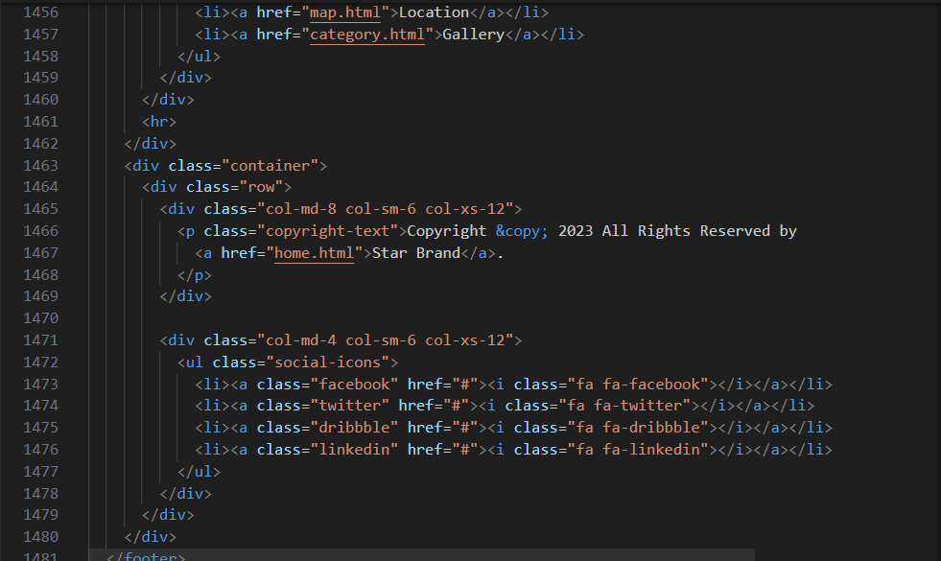

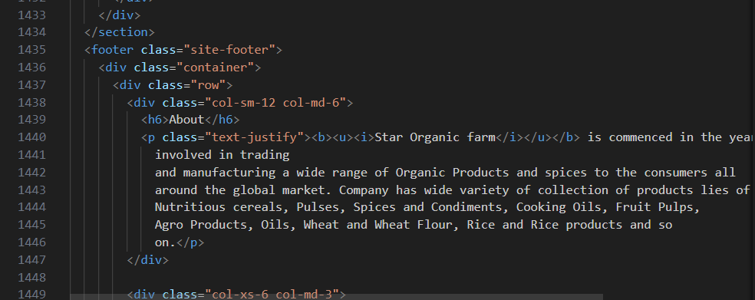

1. **<footer class="site-footer">**: This is the opening tag for the footer section with the class "site-footer."
2. **<div class="container">**: This is a container element that helps structure the content within the footer. It's used to create a consistent layout and spacing.
3. Inside the first **<div class="container">**, there are two **<div>** elements with the class "col-sm-12 col-md-6" and "col-xs-6 col-md-3" respectively. These classes are typically associated with CSS frameworks like Bootstrap and define the column layout for different screen sizes.
4. Within the first column, there is content about the company "Star Organic Farm." It includes a heading (**<h6>**) "About" and a paragraph with a description of the company.
5. In the second column, there's a list of quick links to different pages of the website. This list is wrapped in a **<ul>** element with the class "footer-links," and each list item (**<li>**) contains an anchor (**<a>**) linking to various pages on the website.
6. A horizontal line (**<hr>**) is used to separate the content in the first **<div class="container">**.
7. There's a second **<div class="container">** element, which contains two columns with contact and social media information.
8. In the first column of the second container, there's a copyright notice and a link to the "Star Brand" website.
9. In the second column, there's a list of social media icons with links.

The code provided seems to be a part of a typical footer section of a website. The footer contains information about the company, quick links to important pages, copyright information, and links to the company's social media profiles. The actual layout and design of this footer will depend on the accompanying CSS styles and may also include JavaScript for interactivity, if required.

CSS Code Of Footer :

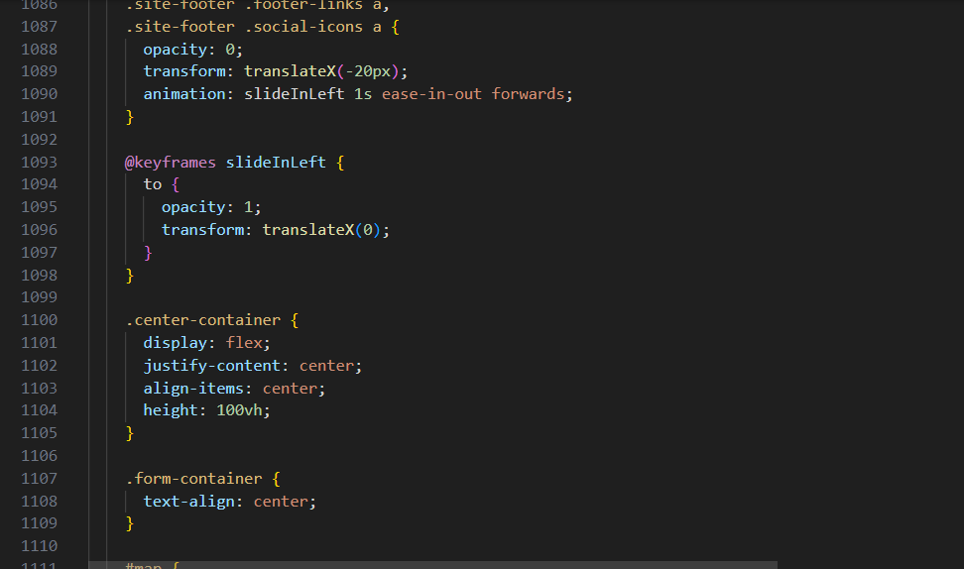

1. **@keyframes slideInLeft**: This defines a keyframe animation named **slideInLeft**.
2. **to**: It represents the final state of the animation.
3. **Opacity: 1**: This sets the opacity to 1, making the links fully visible.
4. **transform: translateX(0);**: This brings the links back to their original horizontal position (0 pixels), which is visible on the screen.

Output Of Footer :

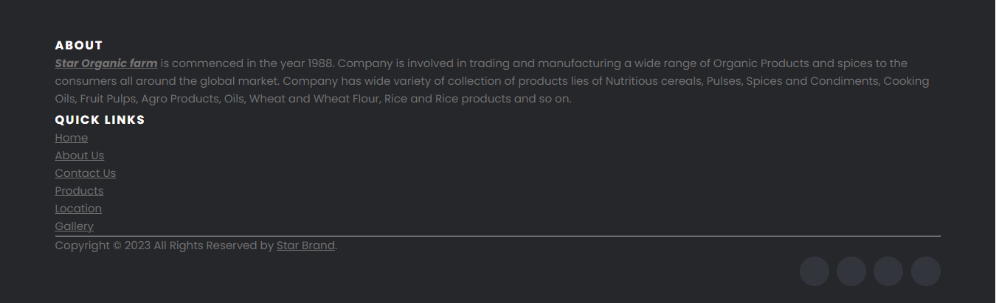

HTML Code Of Map :

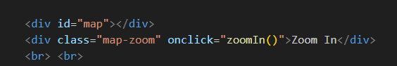

This is code html code for map

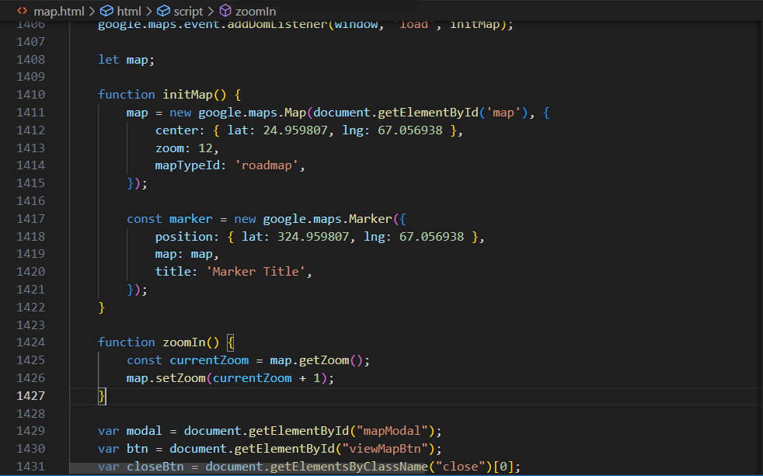CSS Code Of Map :

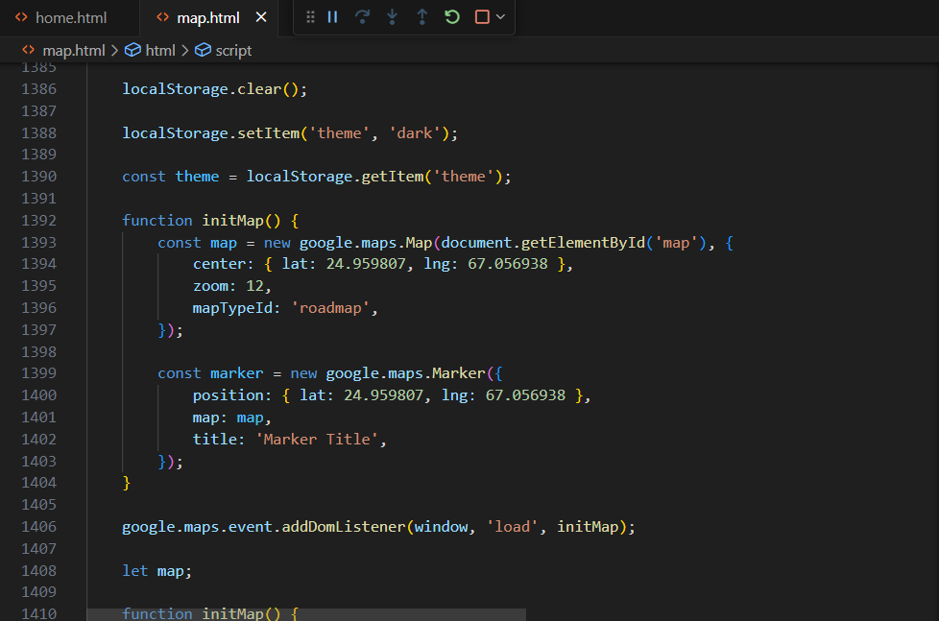

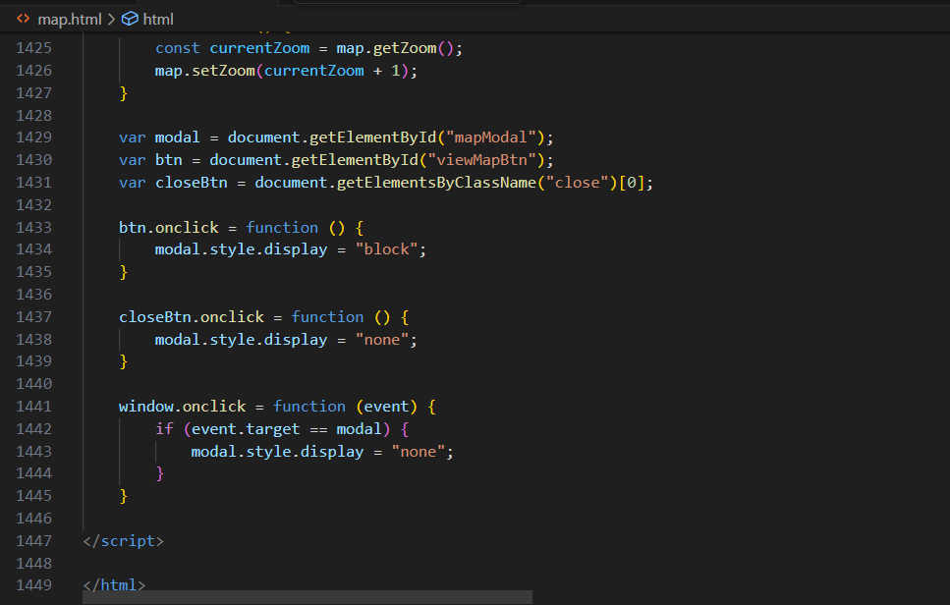

1. **Local Storage Operations**:
   * It sets an item in the browser's local storage with the key "key" and the value "value."
   * It retrieves the value associated with the key "key" from local storage and assigns it to a variable named "value."
   * It removes the item with the key "key" from local storage.
   * It clears all items from the local storage.
   * It sets a new item in local storage with the key "theme" and the value "dark."
   * It retrieves the value associated with the key "theme" from local storage and assigns it to a variable named "theme."
2. **Google Maps Initialization**:
   * It defines a function named "initMap()" to create and initialize a Google Map.
   * Within "initMap()", it creates a Google Map object and adds a marker at the specified coordinates.
   * It adds an event listener to the window to initialize the map when the window loads.
3. **Zooming on Google Map**:
   * It defines a function named "zoomIn()" to zoom in on the Google Map.
   * The function gets the current zoom level of the map and increases it by 1.
4. **Modal Dialog for Map Display**:
   * It references elements with the IDs "mapModal" and "viewMapBtn" and an element with the class "close."
   * When the "viewMapBtn" is clicked, it sets the "mapModal" display style to "block," showing a modal dialog.
   * When the "close" button in the modal is clicked, it hides the modal by setting its display style to "none."
   * It adds a click event listener to the window that closes the modal if the user clicks outside of it.

This code appears to be a combination of features related to local storage, Google Maps integration, and a modal dialog for displaying a map. It is a part of a web page that allows users to view a map with the ability to zoom in and out, open and close a modal dialog for map display, and store/retrieve data in local storage.

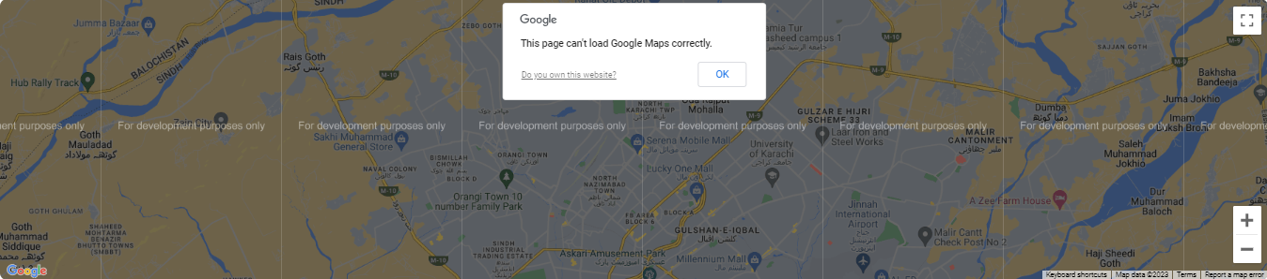 Output Of Map :

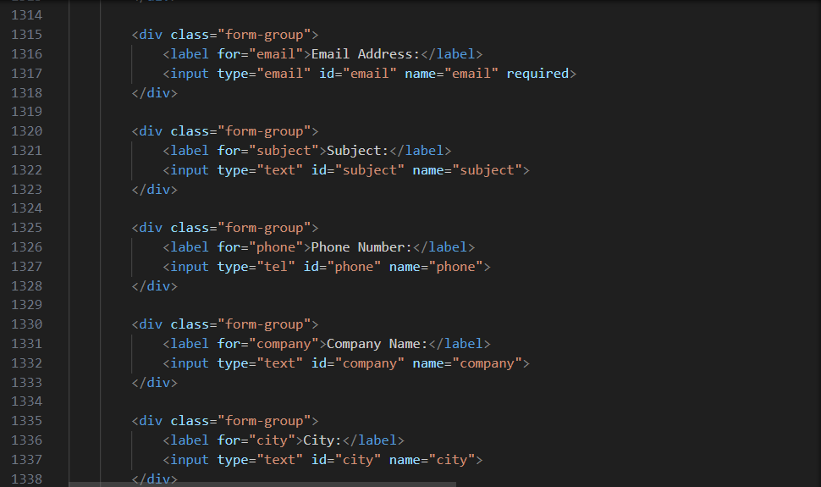HTML Code Of Form :



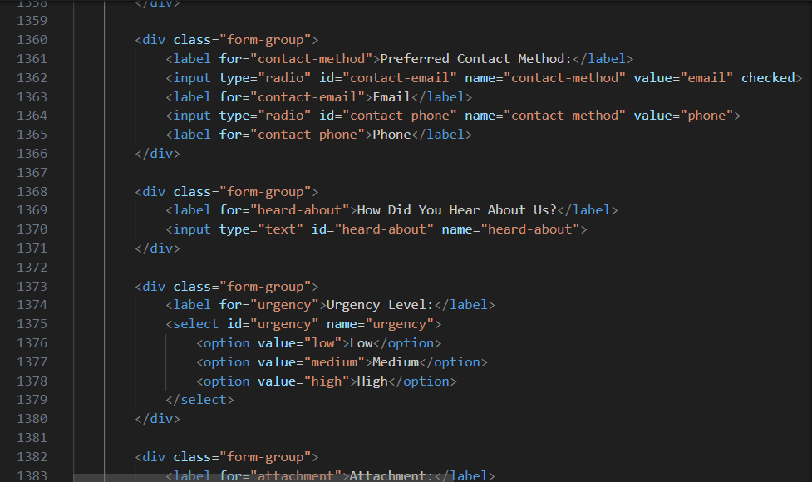

1. ***<*label>** and **<textarea>**:
   * Label: "Message"
   * Textarea input for users to enter a message. It has the **id** "message," **name** "message," and is required. The **rows** attribute specifies the visible number of lines in the textarea.
2. **<label>** and radio buttons:
   * Label: "Preferred Contact Method"
   * Two radio buttons for selecting the preferred contact method, one for "Email" and one for "Phone." The "Email" radio button is checked by default. They share the same **name** "contact-method."
3. **<label>** and **<input>**:
   * Label: "How Did You Hear About Us?"
   * A text input field for users to specify how they heard about the service. It has the **id** "heard-about" and **name** "heard-about."
4. **<label>** and **<select>**:
   * Label: "Urgency Level"
   * A dropdown select menu for users to choose the urgency level. It has the **id** "urgency" and **name** "urgency." It includes options for "Low," "Medium," and "High."
5. **<label>** and **<input>** with type "file":
   * Label: "Attachment"
   * An input field for users to upload a file. It has the **id** "attachment" and **name** "attachment."
6. **<label>** and **<input>**:
   * Label: "Captcha"
   * An input field for users to enter a captcha code. It has the **id** "captcha," **name** "captcha," and a placeholder "Enter the code."
7. **<input>** and a label for checkbox:
   * An input checkbox for users to agree to the "Terms and Conditions." It has the **id** "terms," **name** "terms," and is required. The label is associated with this checkbox.
8. **<input>** and a label for checkbox:
   * An input checkbox for users to indicate that they have read and accept the "Privacy Policy." It has the **id** "privacy-policy," **name** "privacy-policy," and is required. The label is associated with this checkbox.
9. **<input>** and a label for checkbox:
   * An input checkbox for users to subscribe to a newsletter. It has the **id** "subscribe" and **name** "subscribe."
10. **<button>**:
    * A submit button with the text "Submit." It has the class "btn btn-primary."

The form allows users to provide a message, select a preferred contact method, specify how they heard about the service, select an urgency level, upload an attachment, complete a captcha, and agree to terms and privacy policies. It also provides an option to subscribe to a newsletter

CSS Code Of Form :

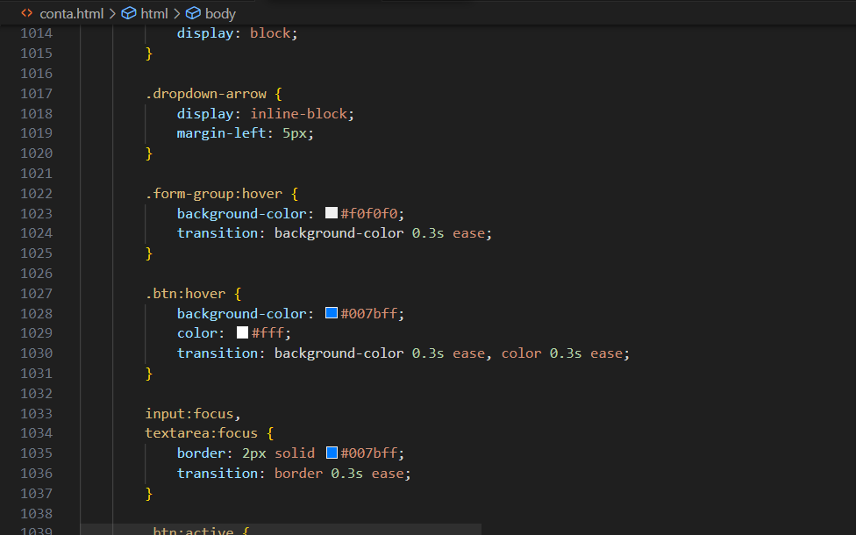

1. **.dropdown-arrow**: This rule targets an element with the class "dropdown-arrow." It sets it to be displayed as an inline block and adds 5 pixels of left margin.
2. **.form-group:hover**: This rule targets elements with the class "form-group" when they are hovered over by the mouse pointer. It changes the background color to a light gray (**#f0f0f0**) and applies a smooth transition effect with a duration of 0.3 seconds.
3. **.btn:hover**: This rule targets buttons with the class "btn" when they are hovered over. It changes the background color to a blue shade (**#007bff**) and the text color to white (**#fff**) on hover. It also applies smooth transition effects for background color and text color, each with a duration of 0.3 seconds.
4. **input:focus, textarea:focus**: This rule targets input and textarea elements when they are in focus (i.e., selected by the user). It adds a 2-pixel solid border with a blue color (**#007bff**) to indicate that the element is in focus. It also applies a smooth transition effect to the border with a duration of 0.3 seconds, making the border change smoothly when the input element gains focus.

These CSS styles are commonly used to enhance the user experience by providing visual feedback during interactions with the web page. For example, when a user hovers over a form element with the class "form-group," the background color changes, creating a visual indicator. Similarly, when a user hovers over a button with the class "btn," the button's appearance changes to give a visual cue that it can be clicked. Lastly, when input or textarea elements gain focus, a border is added to show that they are the active input fields.

Output Of Form :

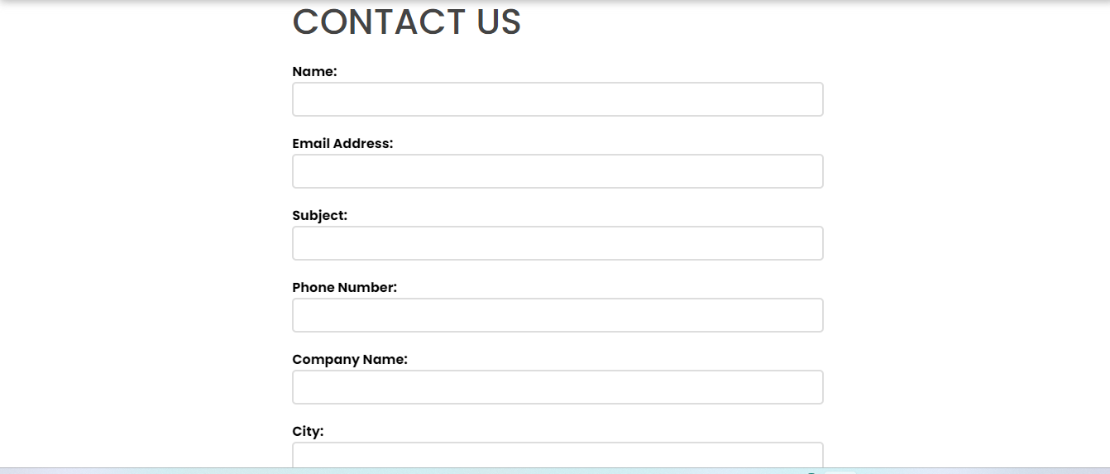

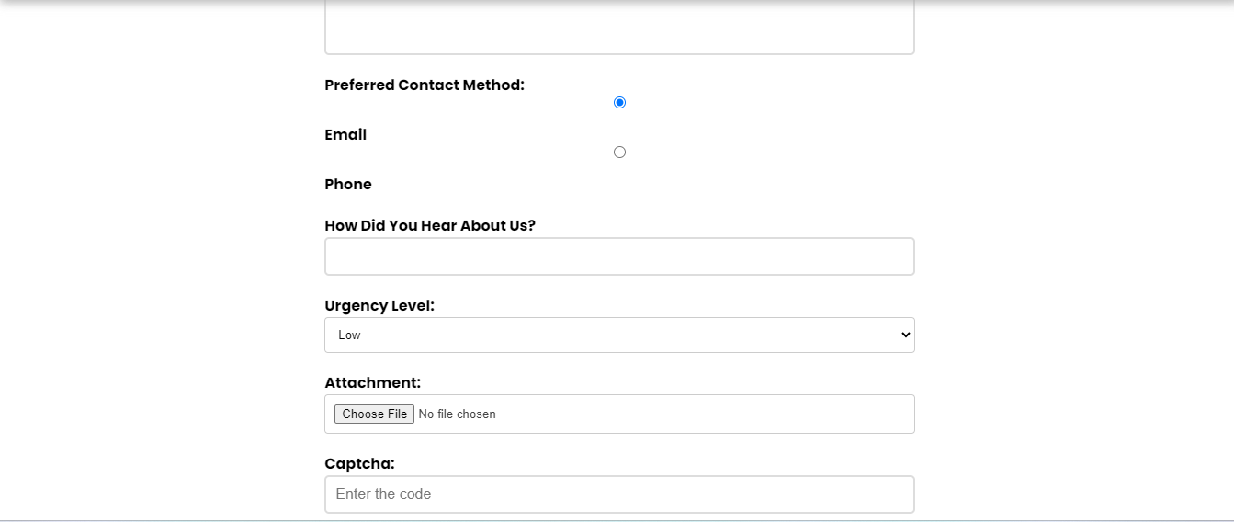

***Thank You For Reading The Documentation.***

***Please Follow The Instruction s Above !!***